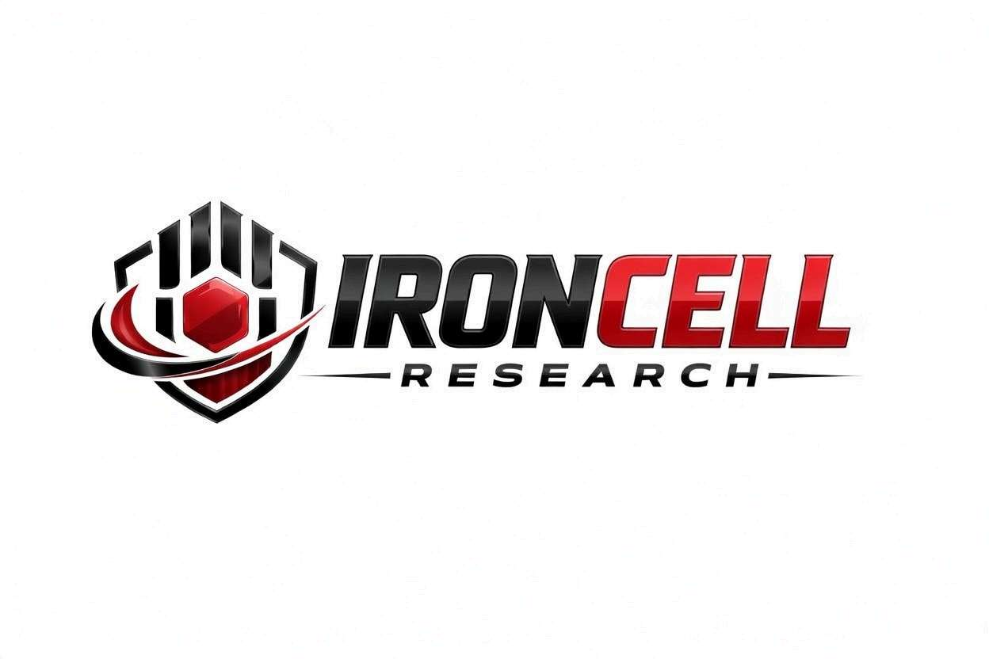
PEPTIDE RESEARCH BRIEF
Ipamorelin
Selective Growth Hormone Secretagogue | Pentapeptide Ghrelin Mimetic

Description, Benefits, Dosage & Research Overview

Iron Cell Research
IronCellResearch.com
For Research Use Only


Compound Overview
Compound Name | Ipamorelin (NNC 26-0161)
Classification | Selective Growth Hormone-Releasing Peptide (GHRP) / Ghrelin Mimetic
Amino Acid Sequence | Aib-His-D-2-Nal-D-Phe-Lys-NH2 (5 amino acids, pentapeptide)
Molecular Formula | C38H49N9O5
Molecular Weight | 711.85 g/mol
CAS Number | 170851-70-4
Biological Half-Life | Approximately 2 hours
Purity | Greater than or equal to 99%
Storage | Lyophilized, -20C, protected from light and moisture
Research Status | Extensive preclinical research; considered the most selective GHRP available

Description
Ipamorelin is a synthetic pentapeptide growth hormone secretagogue developed by Novo Nordisk. It was first characterized in 1998 and has since become recognized as the most selective growth hormone-releasing peptide (GHRP) discovered to date. Ipamorelin mimics the endogenous hormone ghrelin by binding to the growth hormone secretagogue receptor (GHS-R1a) on pituitary somatotrophs, stimulating the release of growth hormone.
What distinguishes Ipamorelin from earlier GHRPs such as GHRP-6, GHRP-2, and hexarelin is its remarkable selectivity. At effective GH-releasing doses, Ipamorelin does not significantly elevate cortisol, prolactin, or aldosterone — hormones that are undesirably increased by older-generation GHRPs. This clean hormonal profile makes Ipamorelin the preferred standalone GHRP and the ideal GHRP partner for combination with GHRH analogs like CJC-1295 (no DAC).
Ipamorelin also produces minimal appetite stimulation compared to GHRP-6, which strongly activates hunger through ghrelin-mediated pathways. This selectivity, combined with its favorable safety profile and consistent GH-releasing efficacy, has made Ipamorelin one of the most widely researched growth hormone secretagogues in the peptide science community.

Mechanism of Action

GHS-R1a Receptor Activation
Ipamorelin binds to the growth hormone secretagogue receptor type 1a (GHS-R1a) on somatotroph cells in the anterior pituitary gland. This receptor signals through a Gq-protein/phospholipase C/IP3 pathway, increasing intracellular calcium concentrations. The calcium influx triggers exocytosis of pre-formed GH-containing secretory vesicles, producing a rapid GH pulse within 15-30 minutes of administration.

Somatostatin Suppression
Ipamorelin functionally antagonizes somatostatin (growth hormone-inhibiting hormone) at the pituitary level. By reducing somatostatin's inhibitory tone, Ipamorelin removes the natural brake on GH release, allowing greater GH pulse amplitude. This is particularly significant when combined with GHRH analogs, as somatostatin suppression allows GHRH signaling to reach the pituitary unopposed.

Selective Receptor Engagement
Unlike GHRP-6 and GHRP-2, Ipamorelin does not significantly activate receptors responsible for ACTH/cortisol release or prolactin secretion. Its binding selectivity for the GHS-R1a receptor over other ghrelin receptor subtypes and unrelated receptors is the molecular basis for its exceptionally clean side-effect profile. This selectivity has been confirmed in dose-response studies up to high doses.

Pulsatile GH Release Pattern
Ipamorelin produces a defined GH pulse with a peak at approximately 30-60 minutes post-injection and a return to baseline within 2-3 hours. This pulsatile pattern preserves physiological GH secretion dynamics, maintains negative feedback through IGF-1 and somatostatin, and prevents receptor desensitization that occurs with continuous GH elevation.

Research Benefits

Growth Hormone Release
- Potent GH Stimulation: Dose-dependent increase in GH release comparable to GHRP-6 at equivalent doses, but without unwanted hormonal side effects.
- Clean Hormonal Profile: Does not significantly elevate cortisol, ACTH, prolactin, or aldosterone at standard GH-releasing doses.
- No Appetite Surge: Minimal ghrelin-mediated hunger stimulation compared to GHRP-6, allowing easier dietary compliance.
- Sustained Efficacy: Maintains consistent GH-releasing potency over extended research protocols without significant tachyphylaxis.

Body Composition
- Fat Reduction: GH-mediated activation of hormone-sensitive lipase promotes lipolysis, particularly in visceral adipose tissue.
- Lean Mass Support: Elevated GH and IGF-1 support muscle protein synthesis, nitrogen retention, and satellite cell activation.
- Body Recomposition: Facilitates simultaneous fat loss and lean tissue preservation, particularly effective alongside resistance training.
- Metabolic Rate: GH-driven increases in lean mass and direct thermogenic effects elevate resting energy expenditure.

Recovery & Tissue Repair
- Muscle Recovery: Enhanced GH pulsatility accelerates post-exercise recovery and reduces muscle damage markers.
- Connective Tissue: IGF-1-mediated collagen synthesis supports tendon, ligament, and cartilage repair and strengthening.
- Bone Health: Ipamorelin has demonstrated direct bone-building effects, stimulating longitudinal bone growth and osteoblast activity in research models.
- Injury Healing: Promotes angiogenesis, fibroblast proliferation, and extracellular matrix remodeling for accelerated tissue repair.

Sleep Quality
- Deep Sleep Enhancement: Pre-bed dosing amplifies the natural nocturnal GH surge that occurs during slow-wave (Stage 3/4) sleep.
- Sleep Architecture: Improved sleep quality and depth reported in research subjects without sedative effects.
- Overnight Recovery: Enhanced nocturnal GH release maximizes the body's natural repair and restoration processes during sleep.

Anti-Aging & Longevity
- Somatopause Reversal: Addresses age-related decline in GH pulse amplitude, restoring more youthful GH/IGF-1 axis function.
- Skin Quality: GH and IGF-1 stimulate dermal collagen production, improving skin thickness, elasticity, and hydration.
- Cognitive Support: IGF-1 supports hippocampal neurogenesis, synaptic plasticity, and neuroprotective signaling.
- Immune Function: GH promotes thymic regeneration and enhances NK cell activity and T-cell function.

Gastrointestinal Function
- GI Motility: Ghrelin receptor activation promotes gastric motility and gut function, potentially beneficial in post-operative ileus.
- Post-Surgical Recovery: Clinical research has evaluated Ipamorelin for accelerating recovery of bowel function following abdominal surgery.

Dosage & Administration
The following dosage information is provided for research reference purposes only.
Protocol | Dose Range | Route | Frequency
Low / Introductory | 100-200 mcg | SubQ Injection | 1x daily (pre-bed)
Standard | 200-300 mcg | SubQ Injection | 1-2x daily
Optimized | 200-300 mcg | SubQ Injection | 2-3x daily (AM, post-workout, pre-bed)
Saturation Dose | 1 mcg/kg body weight | SubQ Injection | Per injection

Optimal Timing Protocol
Pre-Bed (Primary) | Most important dose; amplifies natural nocturnal GH surge during deep sleep
Morning (Fasted) | Upon waking before eating; aligns with natural AM GH pulse
Post-Workout | 30-60 minutes after training; leverages exercise-induced GH priming
Fasting Requirement | Administer on empty stomach (2+ hours fasted); avoid eating 30 min post-injection
Why Fasting Matters | Insulin and blood glucose suppress GH release; fats and carbohydrates are most suppressive

Reconstitution Guidelines
Solvent | Sterile bacteriostatic water
Reconstitution | 1-2 mL BAC water per vial (typically 2 mg or 5 mg vials)
Mixing | Gently swirl until dissolved, never shake
Storage | Refrigerate at 2-8C, use within 21 days once reconstituted
Injection Site | Subcutaneous (abdomen, thigh, deltoid), rotate sites daily
Combination Use | Can be drawn into the same syringe as CJC-1295 (no DAC) for combined injection

Safety Profile
Ipamorelin has one of the most favorable safety profiles among all growth hormone secretagogues:
- General Tolerability: Excellent tolerability across multiple clinical and preclinical studies. The most selective GHRP available with the cleanest side-effect profile.
- No Cortisol Elevation: Does not stimulate ACTH or cortisol release at GH-releasing doses, unlike GHRP-6 and GHRP-2. This preserves adrenal health and avoids catabolic effects.
- No Prolactin Elevation: Does not increase prolactin levels, eliminating concerns about gynecomastia, galactorrhea, or reproductive hormone disruption.
- Minimal Appetite Stimulation: Produces little to no hunger increase, unlike GHRP-6 which strongly stimulates appetite through ghrelin pathways.
- Injection Site: Mild, transient injection site reactions including minor redness or warmth.
- Flushing: Brief facial flushing and warmth may occur 5-15 minutes post-injection, self-resolving.
- Water Retention: Mild, transient fluid retention possible during initial 1-2 weeks, typically self-resolving.
- Tingling: Occasional mild paresthesia (tingling in extremities) associated with GH release, transient.
- Blood Glucose: GH can transiently elevate blood glucose; monitor in insulin-resistant or diabetic subjects.
- Pregnancy & Nursing: Insufficient safety data; not recommended during pregnancy or lactation.

Key References
- Raun K, et al. Ipamorelin, the First Selective Growth Hormone Secretagogue. European Journal of Endocrinology. 1998;139(5):552-561.
- Johansen PB, et al. Ipamorelin, a New Growth-Hormone-Releasing Peptide, Induces Longitudinal Bone Growth in Rats. Growth Hormone & IGF Research. 1999;9(2):106-113.
- Anderson NB, et al. Ipamorelin as a New Growth-Hormone-Releasing Peptide with Improved Safety Profile. Drug Development Research. 2001;54(3):144-151.
- Beck DE, et al. A Prospective, Randomized, Controlled, Proof-of-Concept Study of Perioperative Administration of Ipamorelin to Patients Undergoing Abdominal Surgery. International Journal of Colorectal Disease. 2012;27(6):765-772.
- Gobburu JV, et al. Pharmacokinetic-Pharmacodynamic Modeling of Ipamorelin, a Growth Hormone Releasing Peptide, in Human Volunteers. Pharmaceutical Research. 1999;16(9):1412-1416.
- Hansen BS, et al. The GH Secretagogue Ipamorelin: In Vitro and In Vivo Pharmacology of a Novel Selective GH Secretagogue. Journal of Endocrinological Investigation. 1999;22(5 Suppl):56-63.
- Nass R, et al. Effects of an Oral Ghrelin Mimetic on Body Composition and Clinical Outcomes in Healthy Older Adults. Annals of Internal Medicine. 2008;149(9):601-611.

Contact & Information
Company | Iron Cell Research
Website | IronCellResearch.com
Email | orders@ironcellresearch.com
Product Support | Available via website contact form

Disclaimer
This document is intended for informational and research purposes only. Ipamorelin is sold as a research compound and is not intended for human consumption. The information provided herein does not constitute medical advice, diagnosis, or treatment recommendations. All research applications should comply with applicable institutional, local, and federal regulations. Iron Cell Research makes no claims regarding the therapeutic efficacy of Ipamorelin for any medical condition. Researchers should consult with qualified healthcare professionals and institutional review boards before initiating any research protocols involving human subjects.
Iron Cell Research - For Research Use Only


